2021/2022
PLAYING CONDITIONS
FAIRFIELD LIVERPOOL
CRICKET ASSOCIATION
SENIOR CRICKET
SENIOR COMPETITION RULES — ONE DAY MATCHES
(A) Hours of play shall be 1:00PM to end of over in progress 6.30PM unless a result achieved earlier.
**If play has not commenced by 2.45pm the match is abandoned and deemed a Draw
(B) Drink breaks of not more than five (5) minutes may be taken at no less than hourly intervals after play starts or after an innings commences. (Off field)
(C) If a wicket falls within five (5) minutes of drinks, or if an innings ends or a stoppage occurs for adverse weather conditions within thirty (30) minutes of the anticipated Innings break, the break shall be taken immediately.
(D) One day matches shall be played on a Forty Overs (40) overs innings limit, unless dismissed beforehand. The team scoring the greatest number of runs shall be the winner.
The bowling team will bowl in 10 over spells from the one end before switching.
After 10 overs have been completed they will switch to the opposite end for another 10 over spell and so on each 10 overs.
The Bowling team determines which end they choose to begin their innings from.
Batters will switch ends at the end of each over to ensure to correct batter stays on strike.
(E) All bowlers shall be limited to a maximum of Eight (8) overs each* or 1/5th of the total number available when play commences. *Junior Bowlers are restricted to junior bowling restrictions as listed in these One Day Playing Conditions.
(F) If there has been no loss of time due to ground or weather conditions, the team batting first shall conclude its innings at the completion of the over in progress at the finishing time of 3.25pm. If Forty (40) overs have not already been completed, the team batting second shall then be limited to receiving the same number of overs.
If an Innings is completed prior to 3.25pm, the 10 Minute Innings Break will take place immediately.
(G) A minimum of twenty five (25) overs shall be bowled by both teams to constitute a match, unless a result is achieved beforehand, otherwise it shall be regarded as a draw.
Teams should note the scores after each over from and including the 25th Over in case a countback is needed.
(H) If ground or weather conditions cause a loss of time prior to or during the innings of the team batting first, each team shall deduct one (1) over for every full Seven (7) minutes lost.
All matches must commence by 2.45pm otherwise the match shall be abandoned.
If ground or weather conditions cause a loss of time after the innings of the team batting first or during the Team Batting second’s Innings, the team batting Second must receive 25 overs to constitute a match otherwise it’s deemed a draw - unless a result is achieved beforehand.
(I) If the team batting second does not receive its quota of overs for any reason, the match will be determined by countback. For the purpose of a countback there must be a minimum of 25 overs faced by both teams otherwise it is deemed a draw. Once 25 overs have been completed, the Scores are counted back from both scorebooks at the over where the match finished. The Team with the greater amount in the countback of runs and overs is the winner.
(j) If the innings of each team has been completed and or a result obtained, stumps may be drawn as the match is deemed over.
(K) It is not mandatory for either team to bat its full quota of overs if a declaration is desired, provided that if the team batting first does not wish to bat for its full quota of overs, the team batting second shall still be entitled to bat for its full quota of overs.
(L) A maximum of 14 registered players may be recorded on the Team sheet prior to the toss for the commencement of the game. Only the players whose name appears on the team sheet are eligible to bat or bowl during the game.
(M) Bonus Points: Where matches are being played with Bonus Points
In order for the team batting first to gain one bonus point, it must achieve victory with a run rate one and two thirds times that of the opposition. In order for the team batting second to gain one bonus point, victory must be achieved by the end of the 24th over (or in a reduced overs match, it must bat for no more than 60% of its maximum number of overs).
An easy calculation for one and 2 thirds that of the opposition: Example Team A bats first and scores 150. For the team bowling 2nd they take their 150 scored with the bat and multiply it by 0.60 which equals 90. They must restrict the team batting 2nd to 90. 91 or more runs means no bonus point. The key stat is multiplying x 0.60.
Any eleven of the Fourteen Players declared on the Team Sheet are eligible to bat. All fourteen are eligible to bowl or wicket keep.
Players listed on a team sheet and having no part in the match are not permitted to be entered into mycricket results.
Lightning
Play shall cease immediately in the event that a lightning flash is followed by thunder less than 30 seconds later. Play shall not resume until 30 minutes after the last lightning flash. All players must leave the field immediately.
NO FREE HITS.
NORMAL MCC WIDES. (NO AUTOMATIC LEG SIDE WIDES)
BALL: 2 PIECE 156g RED LEATHER AG THOMPSON BRAND
ALL TEAMS MUST ACCEPT GROUND CHANGES PRIOR TO START IF DIRECTED BY A MEMBER OF THE FLCA EXECUTIVE COMMITTEE.
TOSS: The toss shall be taken no later then 12.45pm and no earlier then 12.30 pm. If a team is not ready to toss at 12.45pm the opposition is entitled to claim the toss. 7 Players must be present at the ground to toss and 7 Players must be ready to commence play at 1pm. Teams are entitled to claim a forfeit if the opposition do not have a minimum of 7 players at the ground once play is ready to start.
OFFICIAL UMPIRES APPOINTED BY FLCA HAVE THE RIGHT TO OVERTURN A DECISION OF THE BATTING TEAM’S SQUARE LEG UMPIRE IF THEY FEEL AN INCORRECT DECISION HAS BEEN MADE.
Umpire Fees for FLCA Seniors is $65 each Per team per Saturday.
Teams forfeiting after 4pm on a Friday Preceding a match shall be fined $100.
If Players are reported under the Code of Conduct and subsequently suspended will incur a 5 Points penalty to his or hers team’s tally on the Points Ladder from the match which the offence took part.
Scorers should sit together and accurately keep score and updating the book with every score and conferring with the other scorer. If the fielding team cannot provide a scorer the batting team will score their own book and the oppositions. Teams should not leave the ground after stumps until both books tally.
The Home team shall mark the boundary with boundary markers or fence, mark Creases, and supply one set of stumps. The visiting team shall also provide one set of stumps. Metal Ferrulled stumps ARE allowed on synthetic pitches in FLCA.
BOUNDARIES: Where possible should be 55 metres minimum.

MAXIMUM SPELLS
JUNIOR BOWLERS PLAYING SENIOR CRICKET IN FLCA ONE DAY MATCH
UNDER 17, 18, 19: 8 OVERS
UNDER 16: 6 OVERS
UNDER 13, 14 15: 5 OVERS

SENIOR COMPETITION RULES — TWO DAY MATCHES
(A) Hours of play shall be 1.00PM to the end of the over in progress at 5.30PM on Day 1 or 65 overs have been played on the day.
Day 2: 1.00PM to the end of the over in progress 5.45PM for a First Innings Result or end of the Over in Progress at 5.30pm if an outright result is being pursued. 65 overs is the maximum overs allowed for the day.
(B) A tea break of Fifteen (15) minutes shall be taken at the completion of the over in progress at 3.15PM. If a wicket falls within 3 minutes of Tea, the Tea break shall be taken immediately provided it isn’t the 9th wicket.
If after 2.45PM an innings closes or there is a stoppage caused by adverse ground or weather conditions, the tea break shall be taken immediately.
(C) Drink breaks of not more than five (5) minutes may be taken at no less than hourly intervals after play starts or after an innings commences. More frequent during heat days.
(D) If a team is 9 wickets down at the scheduled tea break, play will continue for a further 30 minutes. If they are still 9 wickets down after 30 minutes, the Tea break will be taken.
(E) There shall be no restriction on the number of overs bowled by any bowler except those on Junior bowling restrictions. The table for Junior bowlers playing seniors is listed in these 2 Day Playing Conditions.
(F) The team batting first shall be limited to a maximum of Sixty five (65) overs in their first innings, unless dismissed beforehand. The team batting second are entitled to any unused overs which the team batting first did not use. These are whole overs only due to declaration or being dismissed inside 65 overs.
An Innings Break which takes in the Tea Break does not cause any reduction of the 65 Overs maximum for the day. However, an innings break outside of Tea Break requires 2 overs to be deducted from the 65 overs maximum for the day.
The team batting first has a compulsory closure of their innings at the end of 65 overs or stumps on Day 1 with the exception of Rule (H)
(G) If 8 overs or less are lost on the first day, and the team batting first has not declared or been dismissed will have their innings compulsory closed. The team batting second will only receive the equivalent amount of overs to which they bowled.
(H) The team batting first may only continue its first innings on the second day when there has been a loss of more then 8 overs on Day 1. Play will not be over divided time and there must be an actual result, otherwise the match is deemed a Draw. For this calculation, up to 8 completed overs is regarded as 8 overs or less, 8.1 overs and more is regarded as more then 8 overs. The match may continue to a second (2nd) innings to achieve an outright result if one side believes they can obtain an outright result.
The follow on score is 75 runs or more.
Matches pursuing an outright result must finish at the end of the over in progress at 5.30pm or 65 overs maximum for the day.
(I) If the team batting second does not receive its quota of overs for any reason, the match is deemed a draw.
(J) Where no play takes place on the first day due to condition of wicket or ground, the match shall become a one (1) day match.
(K) A maximum of 14 registered players may be recorded on the Team sheet prior to the toss for the commencement of the game. Only the players whose name appears on the team sheet are eligible to bat, bowl or keep during the game.
Any eleven of the Fourteen Players declared on the Team Sheet are eligible to bat. All fourteen are eligible to bowl or wicket keep.
Players listed on a team sheet and having no part in the match are not permitted to be entered into mycricket results.
Lightning
Play shall cease immediately in the event that a lightning flash is followed by thunder less than 30 seconds later. Play shall not resume until 30 minutes after the last lightning flash. All players must leave the field immediately.
BALL: 2 PIECE 156g RED LEATHER AG THOMPSON BRAND
ALL TEAMS MUST ACCEPT GROUND CHANGES PRIOR TO START IF DIRECTED BY A MEMBER OF THE FLCA EXECUTIVE COMMITTEE.
TOSS: The toss shall be taken no later then 12.45pm and no earlier then 12.30 pm. If a team is not ready to toss at 12.45pm the opposition is entitled to claim the toss. 7 Players must be present at the ground to toss and 7 Players must be ready to commence play at 1pm. Teams are entitled to claim a forfeit if the opposition do not have a minimum of 7 players at the ground once play is ready to start.
OFFICIAL UMPIRES APPOINTED BY FLCA HAVE THE RIGHT TO OVERTURN A DECISION OF THE BATTING TEAM’S SQUARE LEG UMPIRE IF THEY FEEL AN INCORRECT DECISION HAS BEEN MADE.
Umpire Fees for FLCA Seniors is $65 each Per team per Saturday.
Teams forfeiting after 4pm on a Friday Preceding a match shall be fined $100.
If Players are reported under the Code of Conduct and subsequently suspended will incur a 5 Points penalty to his or hers team’s tally on the Points Ladder.
Scorers should sit together and accurately keep score and updating the book with every score and conferring with the other scorer. If the fielding team cannot provide a scorer the batting team will score their own book and the oppositions. Teams should not leave the ground after stumps until both books tally.
The Home team shall mark the boundary with boundary markers or fence, mark Creases, and supply one set of stumps. The visiting team shall also provide one set of stumps. Metal Ferrulled stumps ARE allowed on synthetic pitches in FLCA.

MAXIMUM SPELLS
JUNIOR BOWLERS PLAYING SENIOR CRICKET IN FLCA TWO DAY MATCH
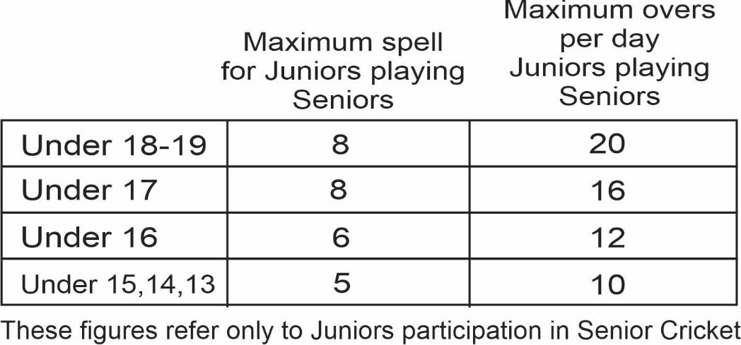

SENIOR MATCHES FORFEITED AFTER 4PM ON THE FRIDAY PRECEDING WILL INCUR $100 FINE
JUNIOR AND SENIOR PLAYERS WHO ARE CITED AND SUSPENDED WILL INCUR A 5 POINTS PENALTY FROM THE COMPETITION TABLE.

